**Array**

* Array is an indexed collection of homogeneous data elements.

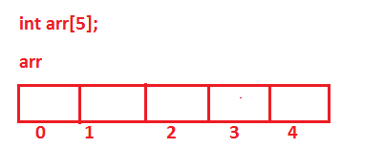

**Read and Display Array Elements**

class ArrayDemo{

public static void main(String args[]){

int arr[] = new int[5];

arr[0] = 10;

arr[1] = 20;

arr[2] = 30;

arr[3] = 40;

arr[4] = 50;

for(int i=0;i<=4;i++){

System.out.println(arr[i]);

}

}

}

**Find Sum of Array Elements**

class ArrayDemo{

public static void main(String args[]){

int arr[] = new int[5];

arr[0] = 10;

arr[1] = 20;

arr[2] = 30;

arr[3] = 40;

arr[4] = 50;

int sum = 0;

// print sum of array element

for(int i=0;i<=4;i++){

sum = sum + arr[i];

}

System.out.println(sum);

}

}

**Array Initialization**

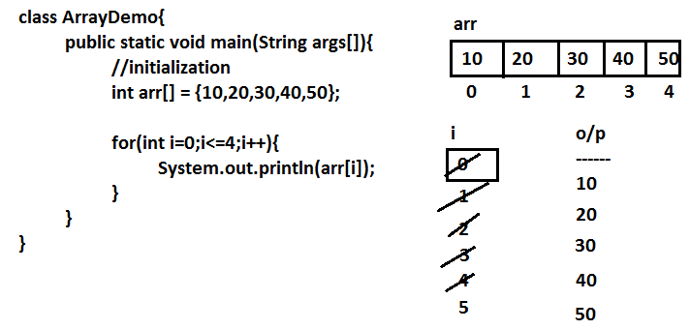

**Display Array Element in Reverse Order**

class ArrayDemo{

public static void main(String args[]){

int arr[] = {10,20,30,40,50};

for(int i=4;i>=0;i--){

System.out.println(arr[i]);

}

}

}